Command 1: grep 'Linux' access.log

Snapshot:

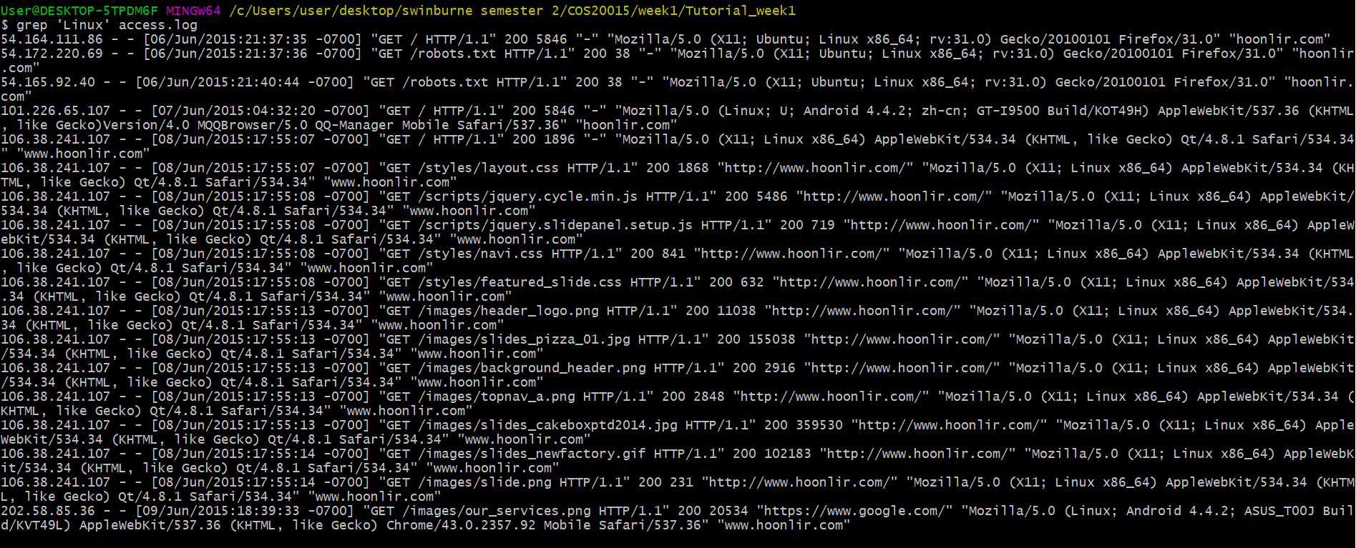

Command 2:

grep 'Linux' access.log | grep -E -c '\<Chrome\>'

grep 'Linux' access.log | grep -E -c '\<Safari\>'

grep 'Linux' access.log | grep -E -c '\<Firefox\>'

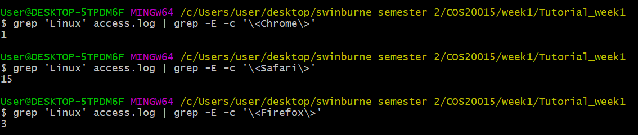Snapshot